Project Report

Project Title : Plugging into Future : An Exploration of Consumption Patterns

1. INTRODUCTION :

Electricity consumption patterns are an important topic that affect both individuals and society as a whole. Understanding how electricity is used and where it is being wasted can help us make informed decisions about energy conservation and sustainability.

* 1. Overview:

The rise of smart technologies and the Internet of Things (IoT), there are now more opportunities than ever to collect and analyze data on energy consumption patterns.

* 1. Purpose:

The purpose of exploring electricity consumption patterns is to gain a better understanding of how energy is being used and wasted in our homes, businesses, and communities. By identifying these patterns, we can make informed decisions about how to conserve energy and reduce our carbon footprint. Additionally, this information can be used to develop more efficient technologies and infrastructure to support a sustainable future. Ultimately, the goal is to promote responsible energy use and ensure that we have access to affordable and reliable electricity for years to come.

1. PROBLEM DEFINING & DESIGNING THINKING:

The problem definition for exploring electricity consumption patterns is that the way we currently consume electricity is not sustainable in the long term. The increasing demand for electricity has led to the depletion of natural resources, pollution, and other environmental issues. Additionally, the cost of electricity is increasing, making it difficult for some individuals and communities to access this essential resource.

* 1. Empathy Map:

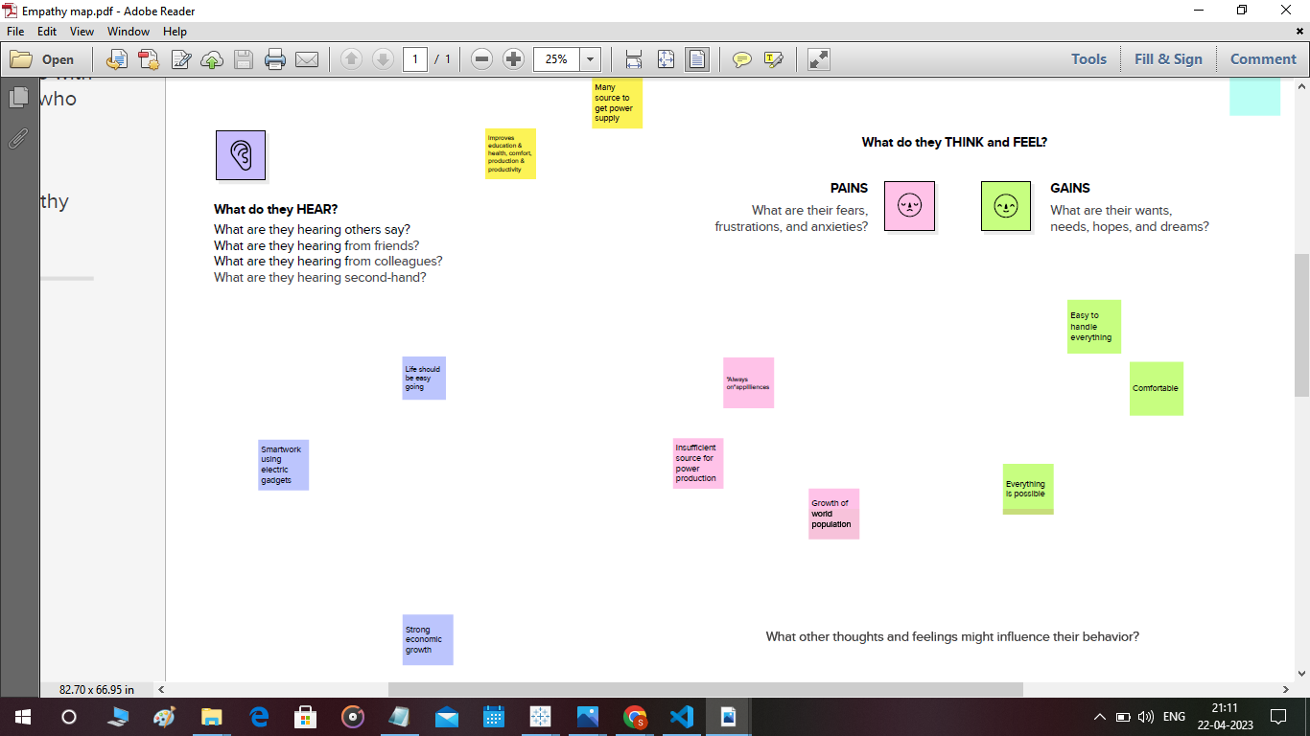

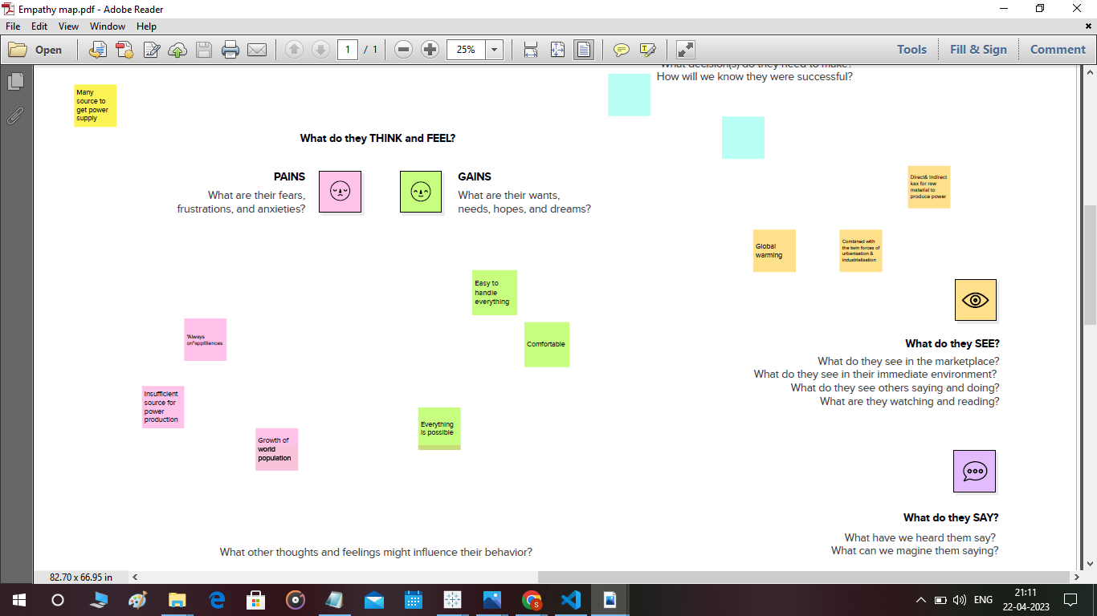

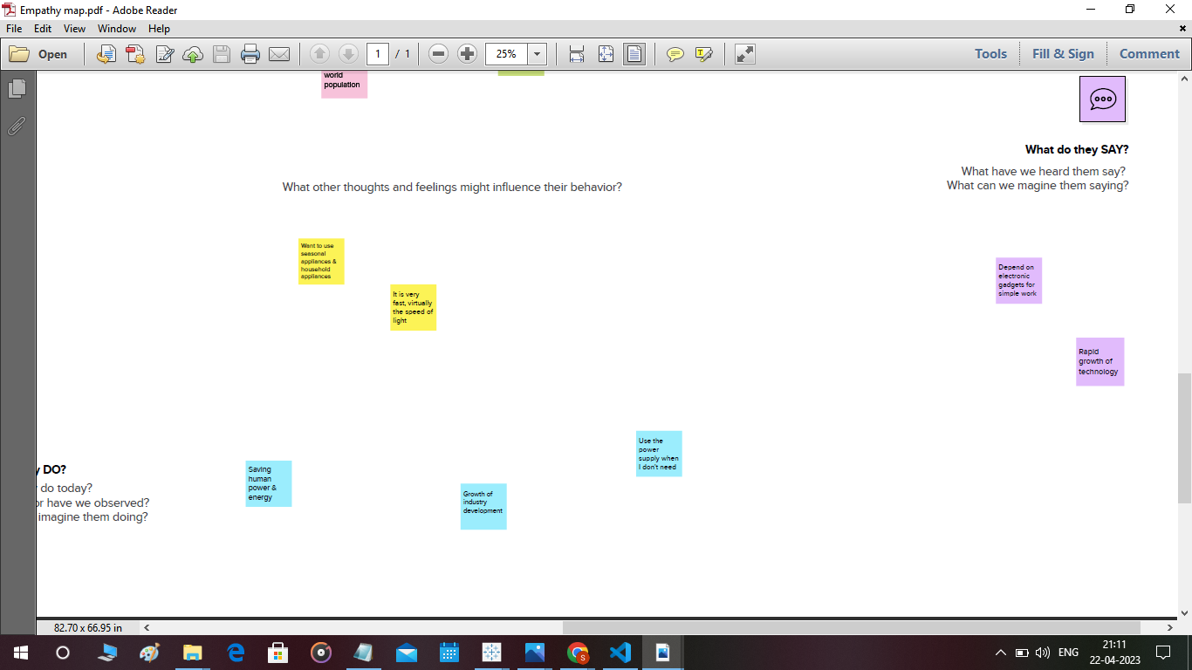

2.2 Ideation & Brain storming Map:

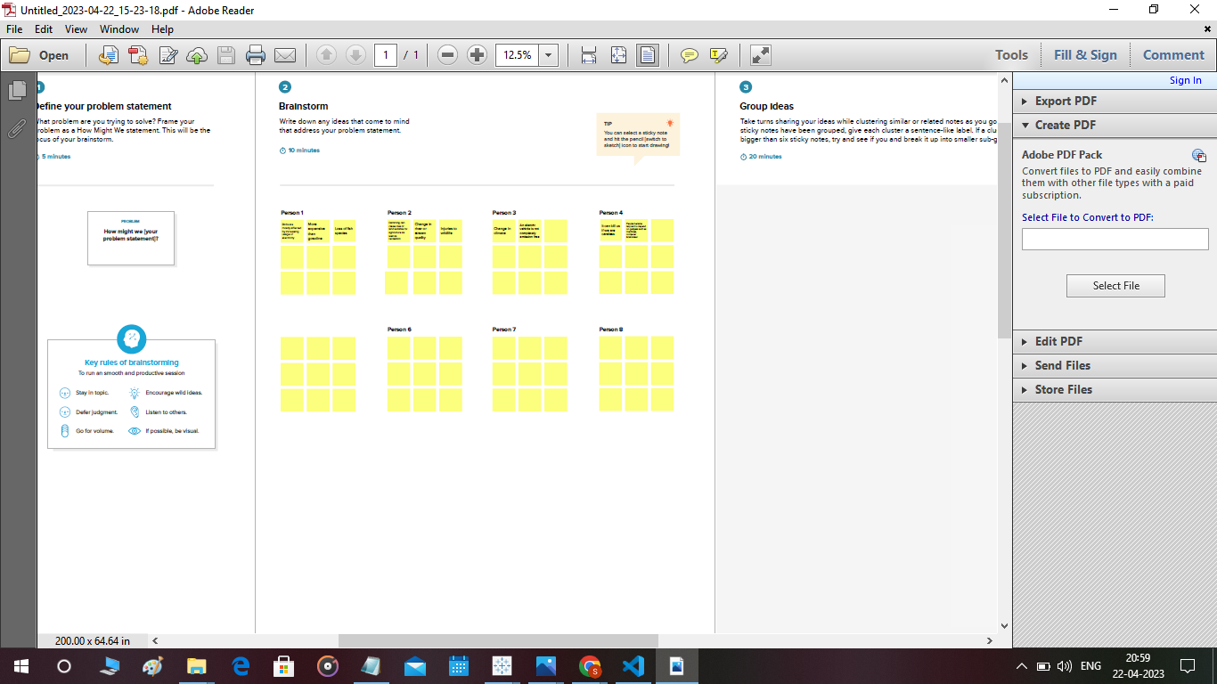

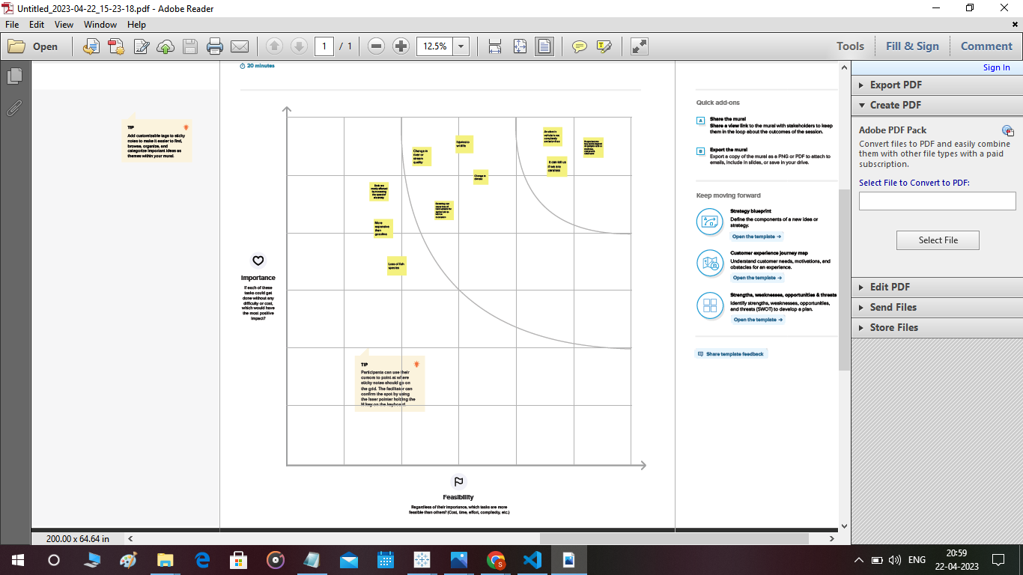

3. RESULT:

3.1 Data Collection & Extraction from Database:

Data collection is the process of gathering and measuring information on variables of interest, in an established systematic fashion that enables one to answer stated research questions, test hypotheses, and evaluate outcomes and generate insights from the data.

3.2 Data Visualization:

2019 State Consumption:

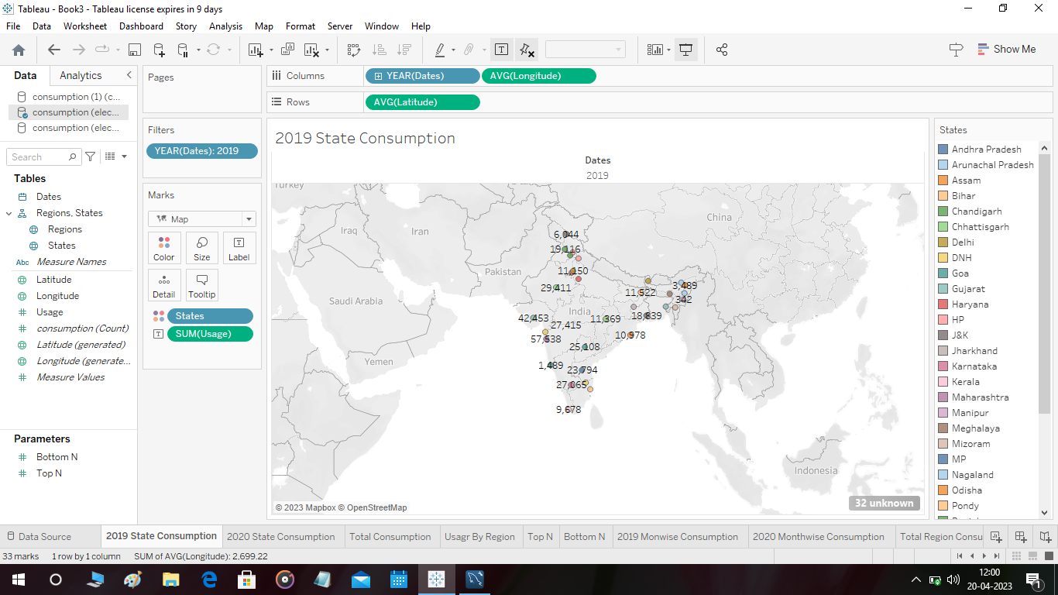

2020 State Consumption :

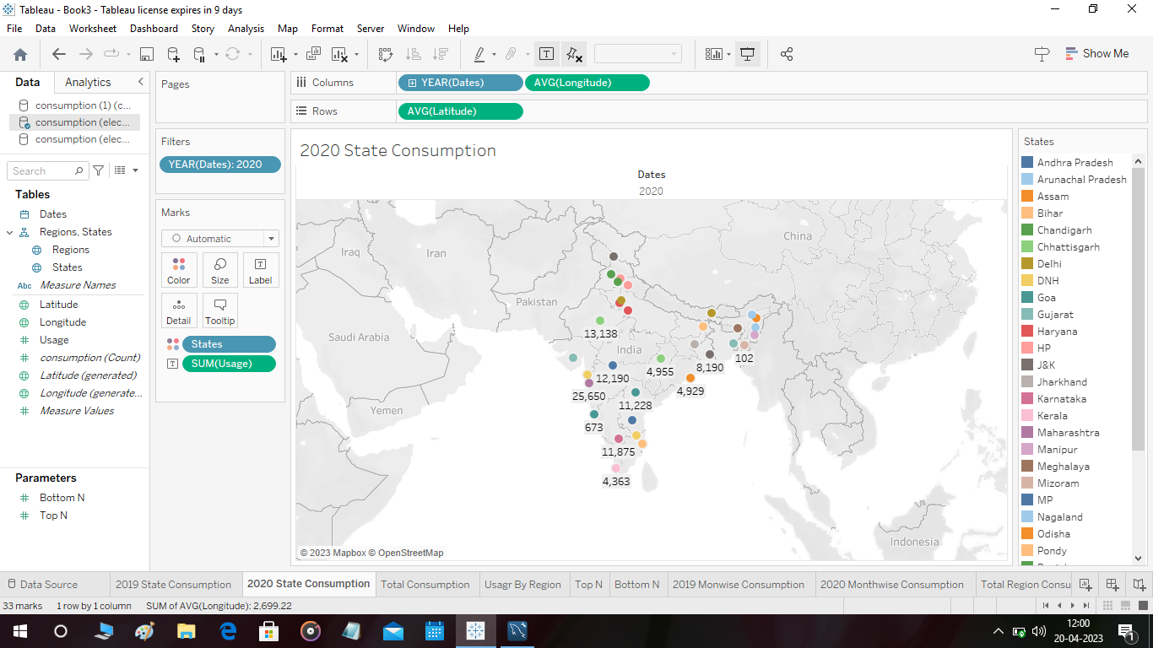

Total Consumption:

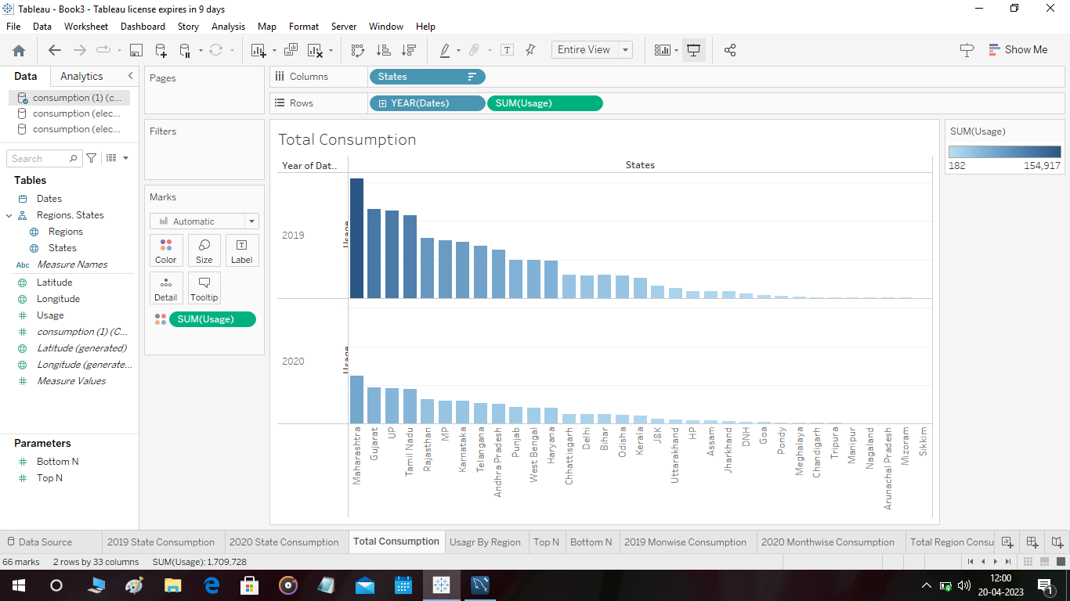

Usage by Region

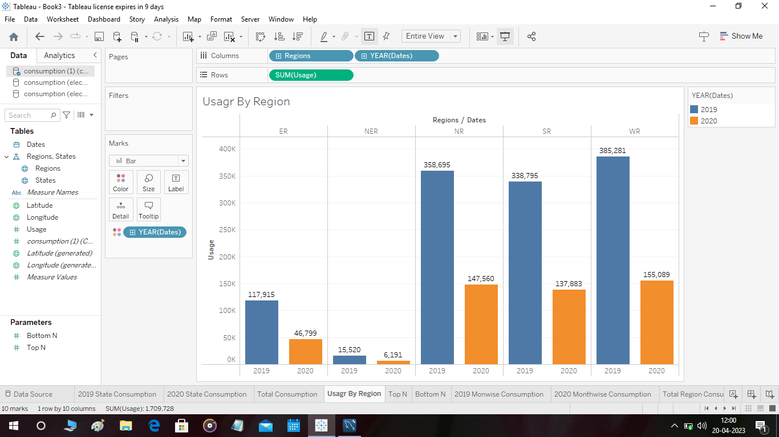

Top N:

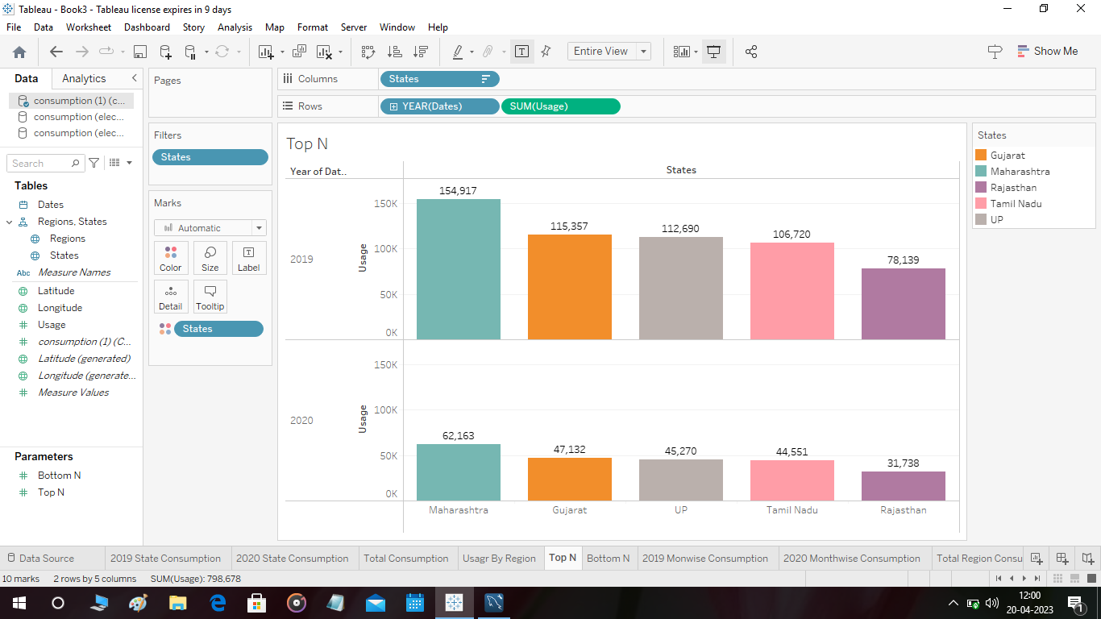

Bottom N:

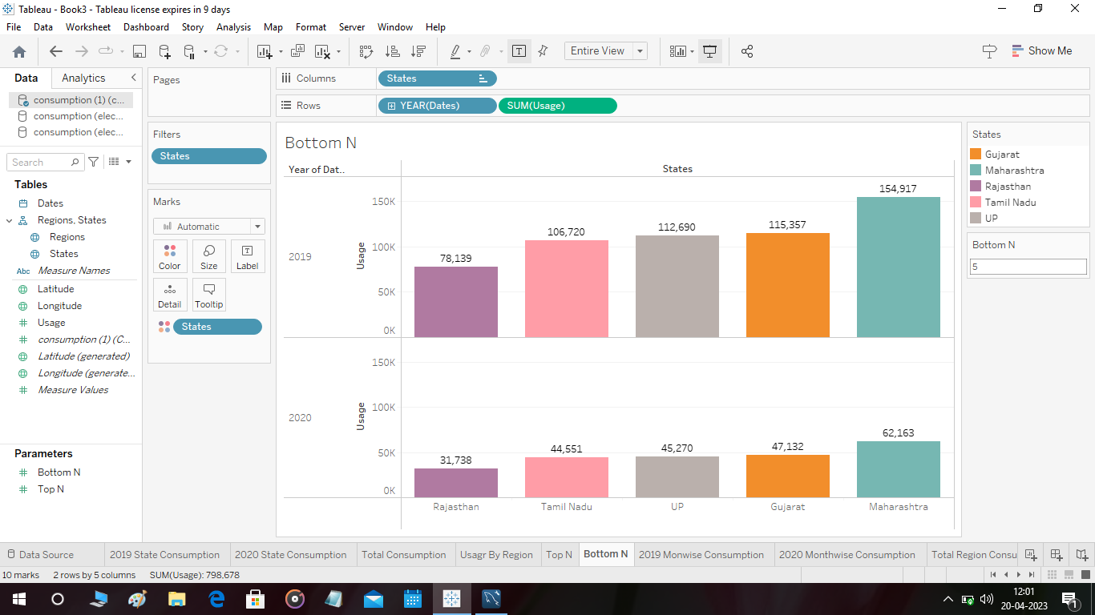

2019 Month wise Consumption:

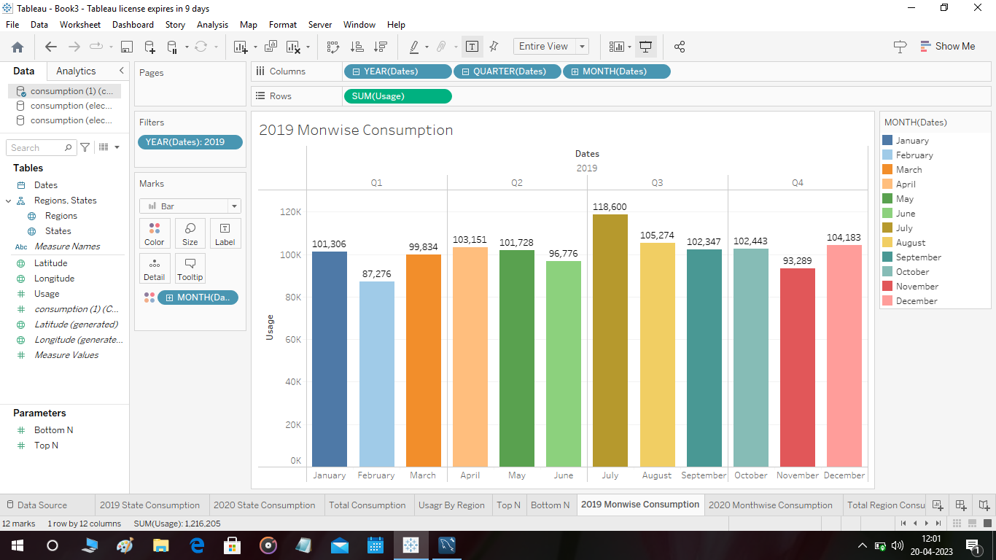

2020 Month wise Consumption:

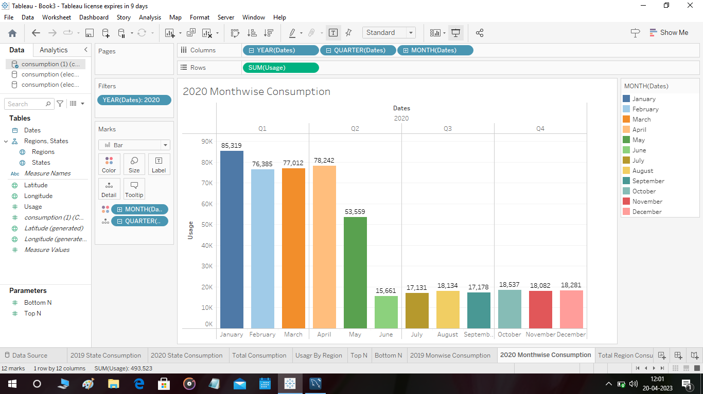

Total Region Consumption:

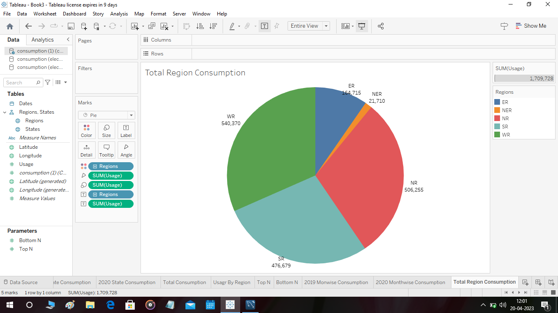

Usage before During Lockdown:

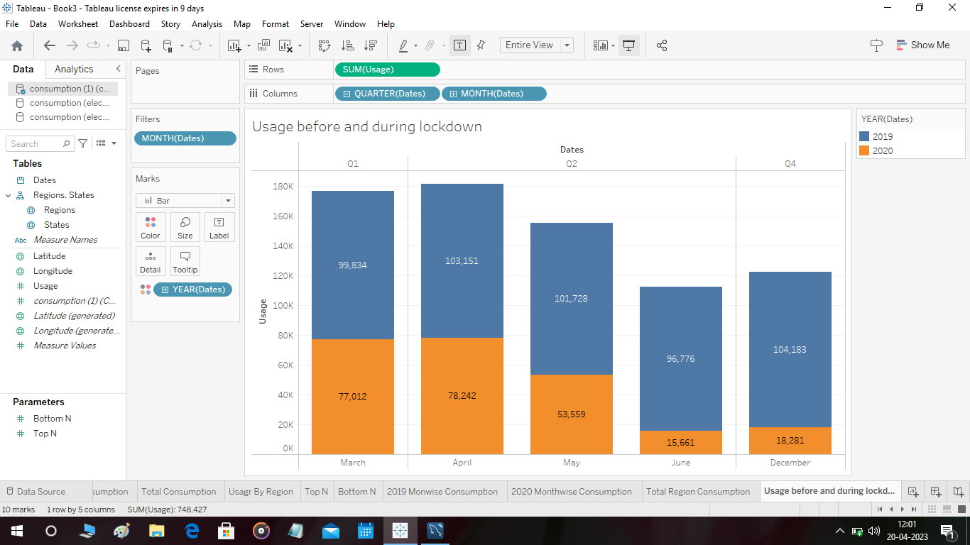

Month wise Top Consumption:

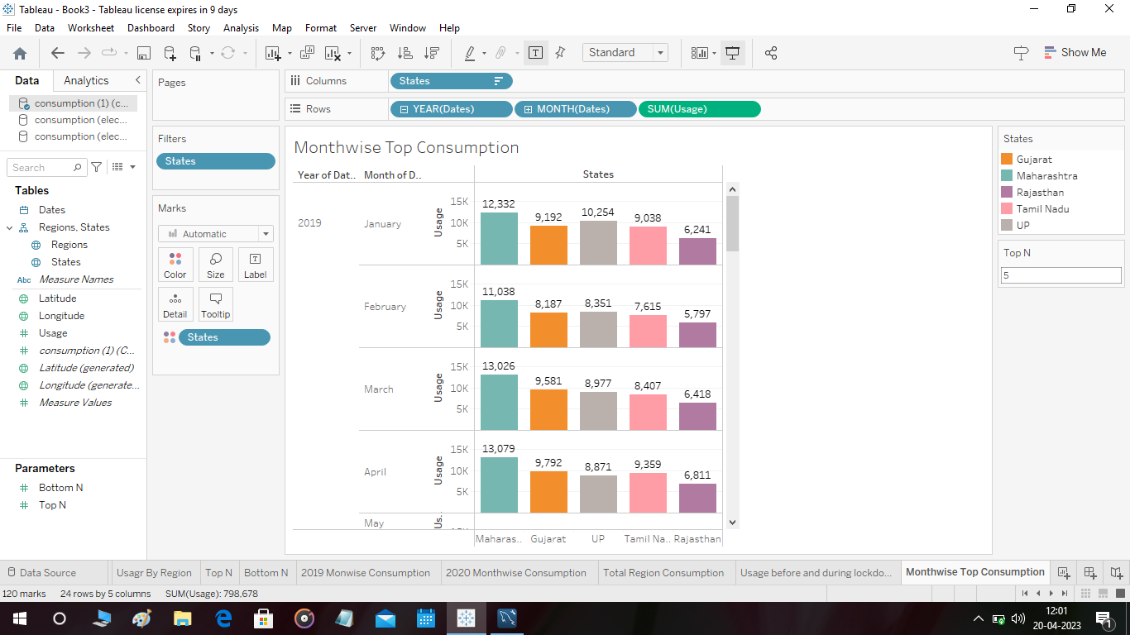

Region wise State Consumption:

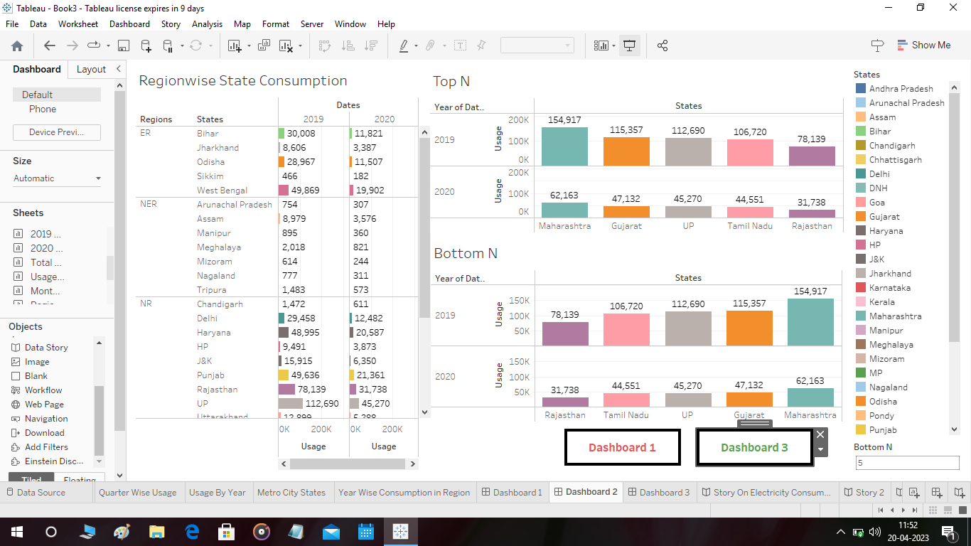

Quarter wise Usage:

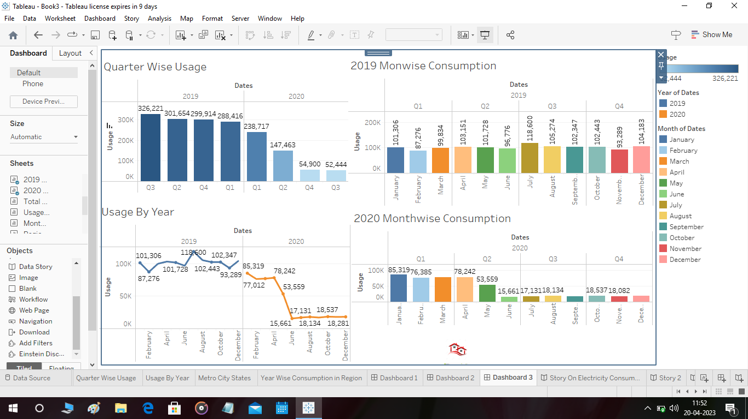

Usage by Year:

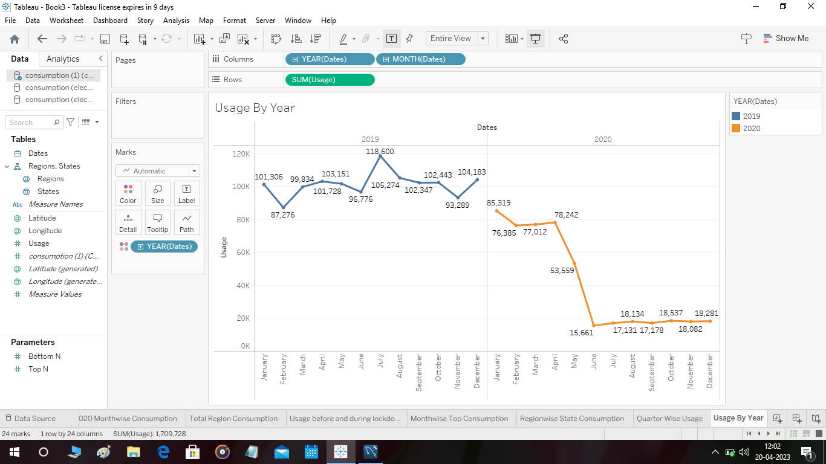

Metro City States:

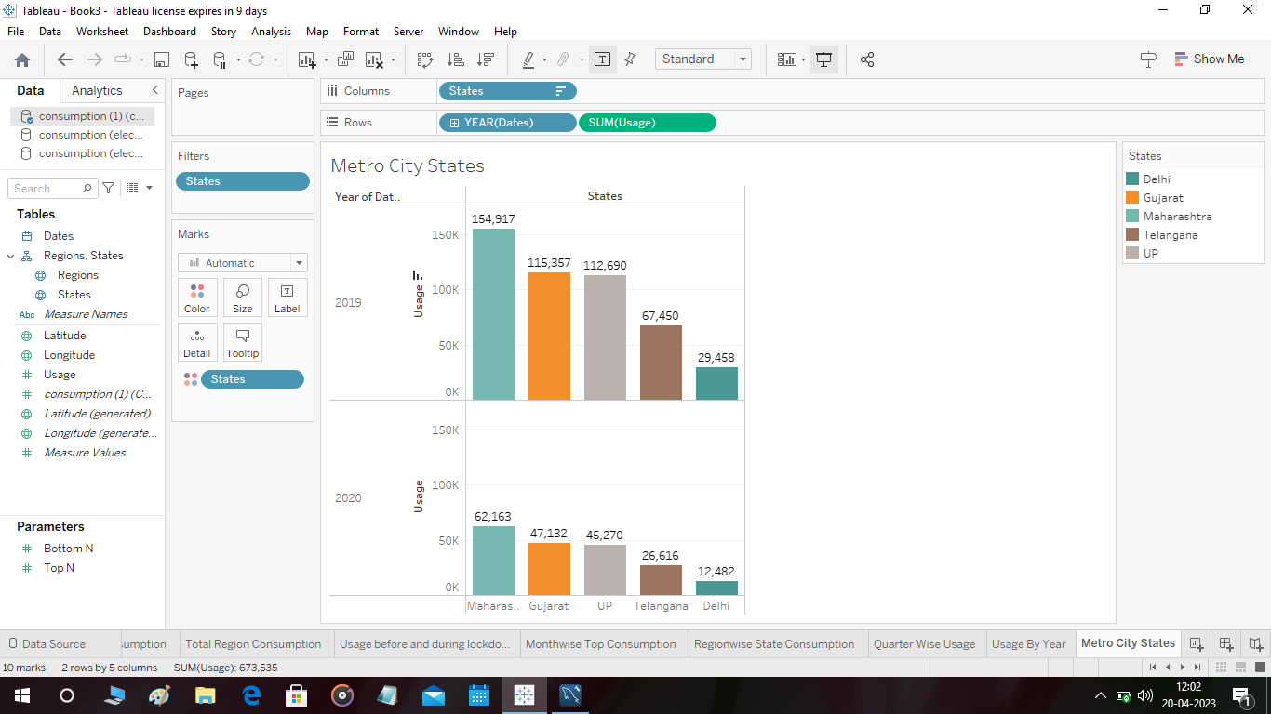

Year wise Consumption in Region:

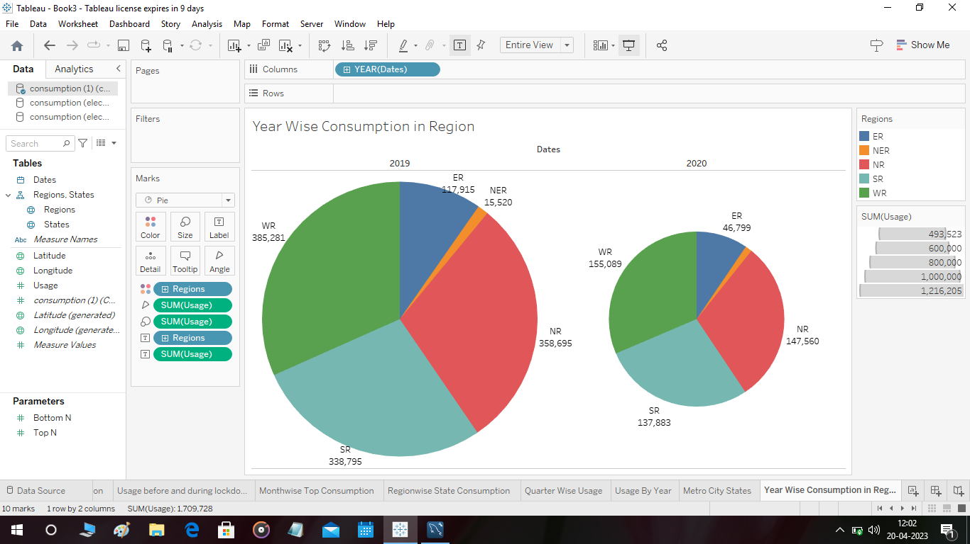

3.3 Dashboard:

A dashboard is a graphical user interface (GUI) that displays information and data in an organized, easy-to-read format. Dashboards are often used to provide real-time monitoring and analysis of data, and are typically designed for a specific purpose or use case.

Dashboard 1:

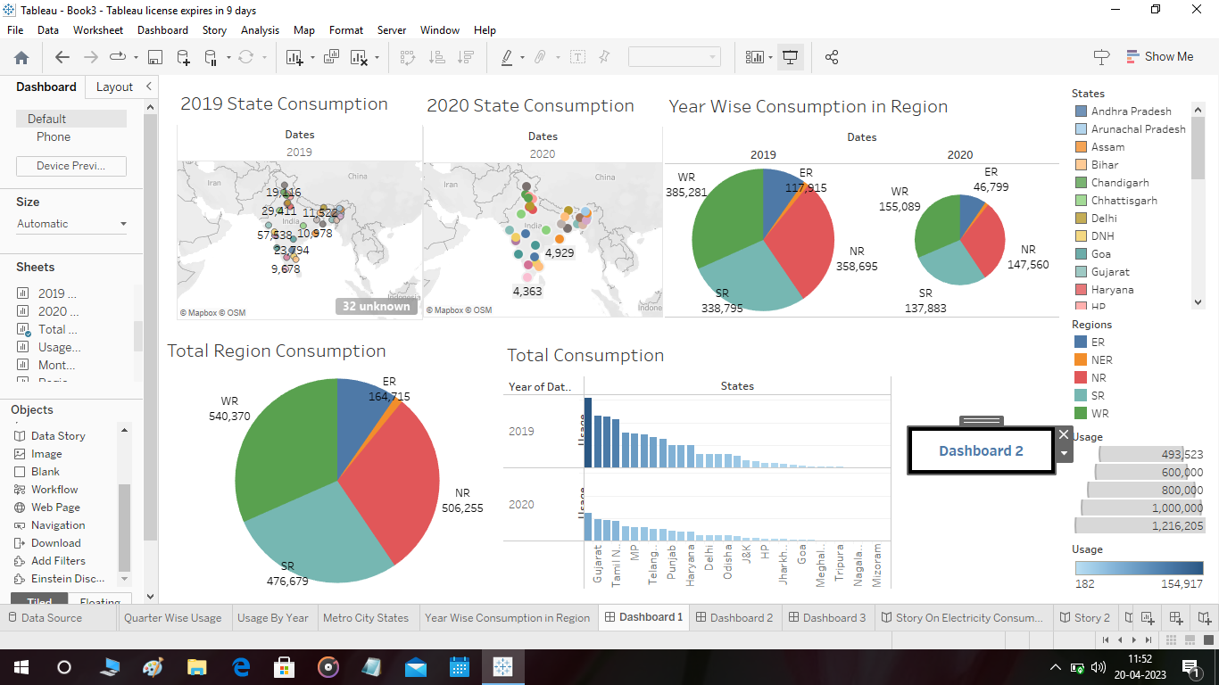

Dashboard 2: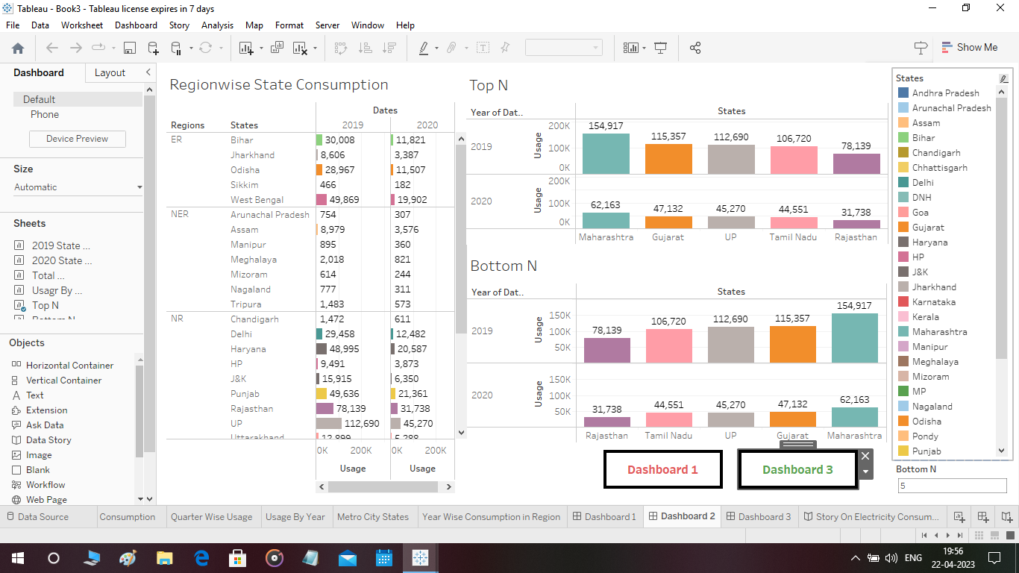

Dashboard 3:

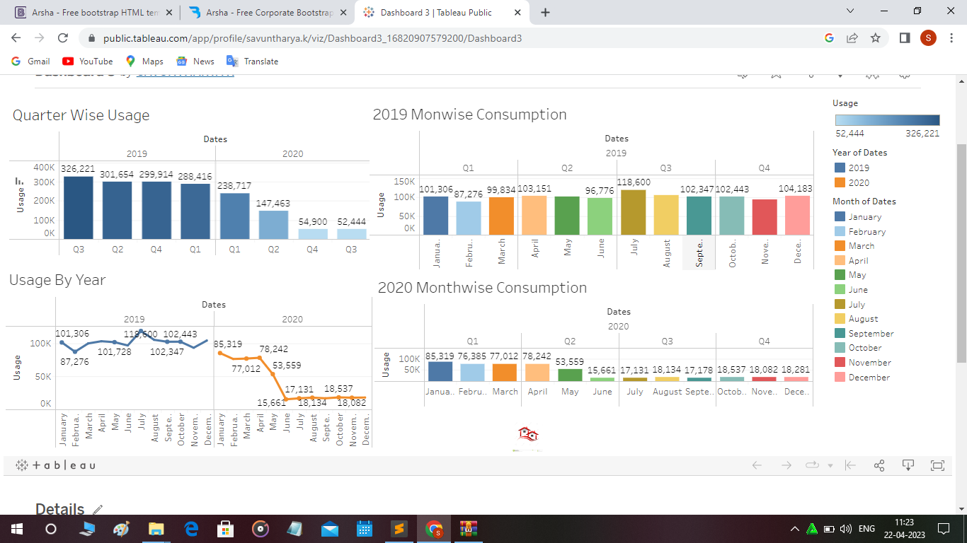

3.4 Story:

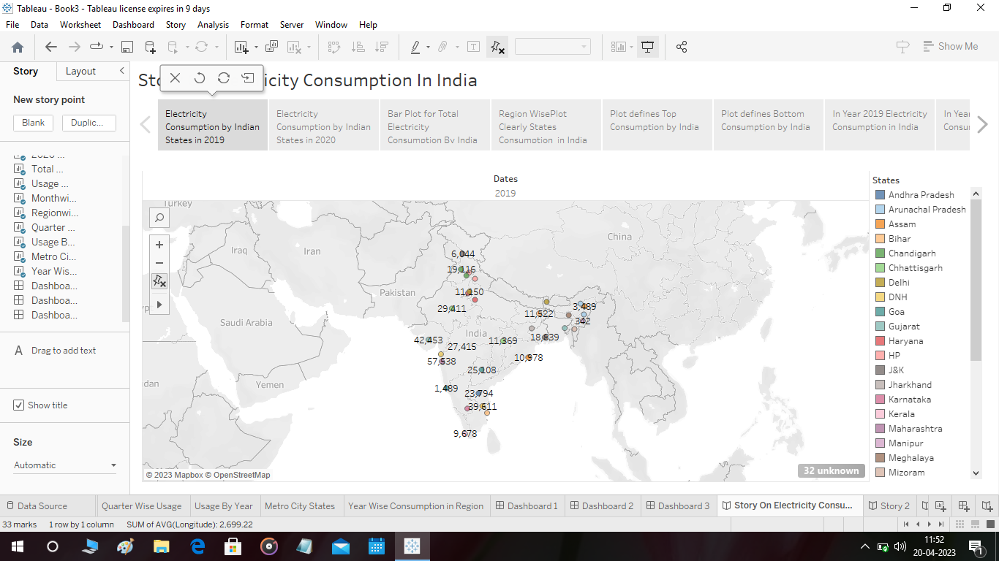

3.5 Web Integration:

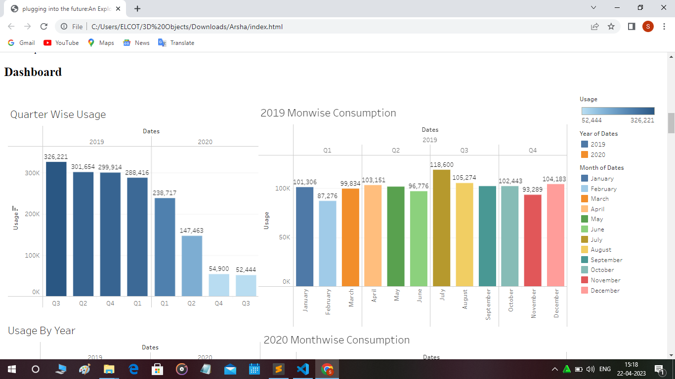

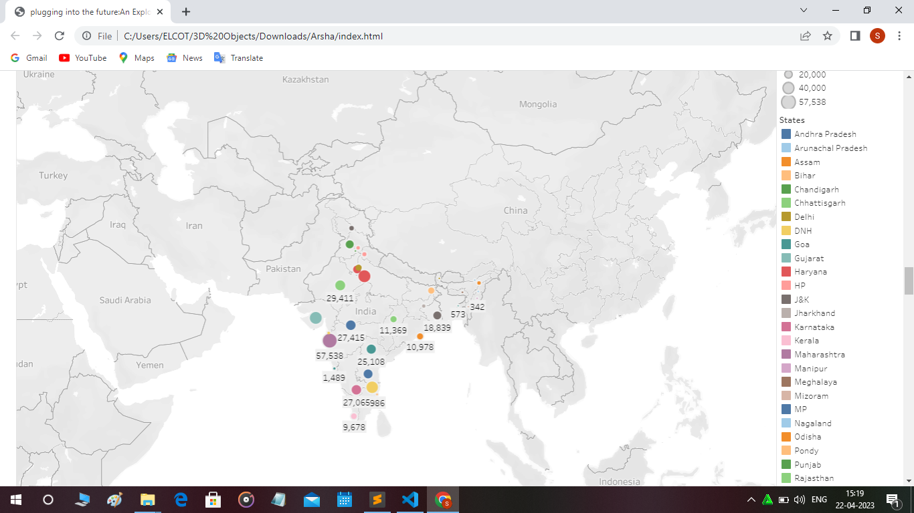

4. ADVANTAGES & DISADVANTAGES:

Advantages:

* Electricity is a clean source of energy and does not produce harmful pollutants or emissions like other forms of energy such as fossil fuels.
* Electricity can be generated from renewable sources such as solar, wind, hydro, and geothermal power. This makes it a sustainable and environmentally friendly option.
* Electricity can be used for a wide range of applications including transportation, heating, cooling, lighting, and powering electronic devices.
* Electricity is easily transported over long distances with minimal loss of energy through transmission lines and grids.
* The availability of electricity has transformed the way people live and work, providing convenience and increasing productivity.

Disadvantages:

* The production of electricity can be expensive and requires significant investment in infrastructure and technology.
* Electricity is dependent on the availability of natural resources and weather conditions for renewable sources of energy such as solar and wind power.
* The use of electricity can contribute to climate change if it is generated from non-renewable sources such as coal and natural gas.
* The production and disposal of batteries used to store electricity can have negative environmental impacts.
* Electrical power systems can be vulnerable to blackoutsand disruptions during extreme weather events or other natural disasters.

5.APPLICATIONS:

* Smart home devices: Smart home devices like smart thermostats, smart plugs, and smart light bulbs can monitor and control your electricity usage in real-time.
* Energy monitoring apps: These apps connect to your smart meter or other monitoring devices to provide detailed information about your energy consumption patterns. Some examples include EnergyHub, Neurio, and Sense.
* Utility company apps: Many utility companies have their own apps that allow you to track your usage, view your bill, and find ways to save on energy.
* Home energy audits: Some companies offer professional energy audits to help you identify areas where you can reduce your energy consumption.

By using these applications, you can gain insight into your energy consumption patterns, identify areas where you can save on energy, and ultimately reduce your carbon footprint.

6. CONCLUSION:

Exploring electricity consumption patterns applications is a great way to become more aware of how we are using energy and identify areas where we can make changes to reduce our energy consumption. By tracking our energy usage in real-time, we can adjust our habits and make smarter choices that lead to a more sustainable future. Whether it's through smart home devices, energy monitoring apps, or professional energy audits, there are many tools available that can help us become more energy-efficient and reduce our carbon footprint.

7.FUTURE SCOPE:

Electricity consumption is an important topic that has been gaining attention for many years. The future of electricity consumption is likely to involve a significant increase in renewable energy sources, such as wind, solar, and hydroelectric power. These sources of energy are becoming more efficient and affordable, making them a popular choice for many consumers. One of the biggest future scopes for electricity consumption is the growth of electric vehicles. As electric cars become more affordable and accessible, the demand for electricity will rise. This could lead to an increase in the use of renewable energy sources, as well as the development of new technologies to store and transport electricity. Another area of growth is in smart homes and buildings. With the use of smart technology, homeowners and businesses can monitor and manage their energy usage more efficiently. This can lead to significant cost savings and a reduction in carbon emissions. Finally, the growth of the Internet of Things(IoT) is likely to have a significant impact on electricity consumption. As more devices are connected to the internet, there will be an increase in the demand for electricity to power these devices.

8. APPENDIX:

Source Code for HTML

!DOCTYPE html>

<html lang="en">

<head>

<meta charset="utf-8">

<meta content="width=device-width, initial-scale=1.0" name="viewport">

<title>Electricity Consumption Pattern - Index</title>

<meta content="" name="description">

<meta content="" name="keywords">

<!-- Favicons -->

<link href="assets/img/favicon.png" rel="icon">

<link href="assets/img/apple-touch-icon.png" rel="apple-touch-icon">

<!-- Google Fonts -->

<link href="https://fonts.googleapis.com/css?family=Open+Sans:300,300i,400,400i,600,600i,700,700i|Jost:300,300i,400,400i,500,500i,600,600i,700,700i|Poppins:300,300i,400,400i,500,500i,600,600i,700,700i" rel="stylesheet">

<!-- Vendor CSS Files -->

<link href="assets/vendor/aos/aos.css" rel="stylesheet">

<link href="assets/vendor/bootstrap/css/bootstrap.min.css" rel="stylesheet">

<link href="assets/vendor/bootstrap-icons/bootstrap-icons.css" rel="stylesheet">

<link href="assets/vendor/boxicons/css/boxicons.min.css" rel="stylesheet">

<link href="assets/vendor/glightbox/css/glightbox.min.css" rel="stylesheet">

<link href="assets/vendor/remixicon/remixicon.css" rel="stylesheet">

<link href="assets/vendor/swiper/swiper-bundle.min.css" rel="stylesheet">

<!-- Template Main CSS File -->

<link href="assets/css/style.css" rel="stylesheet">

<!-- =======================================================

* Template Name: Arsha

* Updated: Mar 10 2023 with Bootstrap v5.2.3

* Template URL: https://bootstrapmade.com/arsha-free-bootstrap-html-template-corporate/

* Author: BootstrapMade.com

* License: https://bootstrapmade.com/license/

======================================================== -->

</head>

<body>

<!-- ======= Header ======= -->

<header id="header" class="fixed-top ">

<div class="container d-flex align-items-center">

<h1 class="logo me-auto"><a href="index.html">Arsha</a></h1>

<!-- Uncomment below if you prefer to use an image logo -->

<!-- <a href="index.html" class="logo me-auto"><img src="assets/img/logo.png" alt="" class="img-fluid"></a>-->

<nav id="navbar" class="navbar">

<ul>

<li><a class="nav-link scrollto active" href="#hero">Home</a></li>

<li><a class="nav-link scrollto" href="#about">About</a></li>

<li><a class="nav-link scrollto" href="#services">Dashboard</a></li>

<li><a class="nav-link scrollto" href="#portfolio">Stroy</a></li>

<li><a class="nav-link scrollto" href="#team">Team</a></li>

<li class="dropdown"><a href="#"><span>Drop Down</span> <i class="bi bi-chevron-down"></i></a>

<ul>

<li><a href="#">Drop Down 1</a></li>

<li class="dropdown"><a href="#"><span>Deep Drop Down</span> <i class="bi bi-chevron-right"></i></a>

<ul>

<li><a href="#">Deep Drop Down 1</a></li>

<li><a href="#">Deep Drop Down 2</a></li>

<li><a href="#">Deep Drop Down 3</a></li>

<li><a href="#">Deep Drop Down 4</a></li>

<li><a href="#">Deep Drop Down 5</a></li>

</ul>

</li>

<li><a href="#">Drop Down 2</a></li>

<li><a href="#">Drop Down 3</a></li>

<li><a href="#">Drop Down 4</a></li>

</ul>

</li>

<li><a class="nav-link scrollto" href="#contact">Contact</a></li>

<li><a class="getstarted scrollto" href="#about">Get Started</a></li>

</ul>

<i class="bi bi-list mobile-nav-toggle"></i>

</nav><!-- .navbar -->

</div>

</header><!-- End Header -->

<!-- ======= Hero Section ======= -->

<section id="hero" class="d-flex align-items-center">

<div class="container">

<div class="row">

<div class="col-lg-6 d-flex flex-column justify-content-center pt-4 pt-lg-0 order-2 order-lg-1" data-aos="fade-up" data-aos-delay="200">

<h1>Electricity Consumption Pattern</h1>

<h2>We are team of talented designers making websites with Bootstrap</h2>

<div class="d-flex justify-content-center justify-content-lg-start">

<a href="#about" class="btn-get-started scrollto">Get Started</a>

<a href="https://www.youtube.com/watch?v=jDDaplaOz7Q" class="glightbox btn-watch-video"><i class="bi bi-play-circle"></i><span>Watch Video</span></a>

</div>

</div>

<div class="col-lg-6 order-1 order-lg-2 hero-img" data-aos="zoom-in" data-aos-delay="200">

<img src="assets/img/hero-img.png" class="img-fluid animated" alt="">

</div>

</div>

</div>

</section><!-- End Hero -->

<main id="main">

<!-- ======= Clients Section ======= -->

<section id="clients" class="clients section-bg">

<div class="container">

<div class="row" data-aos="zoom-in">

<div class="col-lg-2 col-md-4 col-6 d-flex align-items-center justify-content-center">

<img src="assets/img/clients/client-1.png" class="img-fluid" alt="">

</div>

<div class="col-lg-2 col-md-4 col-6 d-flex align-items-center justify-content-center">

<img src="assets/img/clients/client-2.png" class="img-fluid" alt="">

</div>

<div class="col-lg-2 col-md-4 col-6 d-flex align-items-center justify-content-center">

<img src="assets/img/clients/client-3.png" class="img-fluid" alt="">

</div>

<div class="col-lg-2 col-md-4 col-6 d-flex align-items-center justify-content-center">

<img src="assets/img/clients/client-4.png" class="img-fluid" alt="">

</div>

<div class="col-lg-2 col-md-4 col-6 d-flex align-items-center justify-content-center">

<img src="assets/img/clients/client-5.png" class="img-fluid" alt="">

</div>

<div class="col-lg-2 col-md-4 col-6 d-flex align-items-center justify-content-center">

<img src="assets/img/clients/client-6.png" class="img-fluid" alt="">

</div>

</div>

</div>

</section><!-- End Cliens Section -->

<!-- ======= About Us Section ======= -->

<section id="about" class="about">

<div class="container" data-aos="fade-up">

<div class="section-title">

<h2>About Us</h2>

</div>

<div class="row content">

<div class="col-lg-6">

<p>

Lorem ipsum dolor sit amet, consectetur adipiscing elit, sed do eiusmod tempor incididunt ut labore et dolore

magna aliqua.

</p>

<ul>

<li><i class="ri-check-double-line"></i> Ullamco laboris nisi ut aliquip ex ea commodo consequat</li>

<li><i class="ri-check-double-line"></i> Duis aute irure dolor in reprehenderit in voluptate velit</li>

<li><i class="ri-check-double-line"></i> Ullamco laboris nisi ut aliquip ex ea commodo consequat</li>

</ul>

</div>

<div class="col-lg-6 pt-4 pt-lg-0">

<p>

Ullamco laboris nisi ut aliquip ex ea commodo consequat. Duis aute irure dolor in reprehenderit in voluptate

velit esse cillum dolore eu fugiat nulla pariatur. Excepteur sint occaecat cupidatat non proident, sunt in

culpa qui officia deserunt mollit anim id est laborum.

</p>

<a href="#" class="btn-learn-more">Learn More</a>

</div>

</div>

</div>

</section><!-- End About Us Section -->

<!-- ======= Why Us Section ======= -->

<section id="why-us" class="why-us section-bg">

<div class="container-fluid" data-aos="fade-up">

<div class="row">

<div class="col-lg-7 d-flex flex-column justify-content-center align-items-stretch order-2 order-lg-1">

<div class="content">

<h3>Eum ipsam laborum deleniti <strong>velit pariatur architecto aut nihil</strong></h3>

<p>

Lorem ipsum dolor sit amet, consectetur adipiscing elit, sed do eiusmod tempor incididunt ut labore et dolore magna aliqua. Duis aute irure dolor in reprehenderit

</p>

</div>

<div class="accordion-list">

<ul>

<li>

<a data-bs-toggle="collapse" class="collapse" data-bs-target="#accordion-list-1"><span>01</span> Non consectetur a erat nam at lectus urna duis? <i class="bx bx-chevron-down icon-show"></i><i class="bx bx-chevron-up icon-close"></i></a>

<div id="accordion-list-1" class="collapse show" data-bs-parent=".accordion-list">

<p>

Feugiat pretium nibh ipsum consequat. Tempus iaculis urna id volutpat lacus laoreet non curabitur gravida. Venenatis lectus magna fringilla urna porttitor rhoncus dolor purus non.

</p>

</div>

</li>

<li>

<a data-bs-toggle="collapse" data-bs-target="#accordion-list-2" class="collapsed"><span>02</span> Feugiat scelerisque varius morbi enim nunc? <i class="bx bx-chevron-down icon-show"></i><i class="bx bx-chevron-up icon-close"></i></a>

<div id="accordion-list-2" class="collapse" data-bs-parent=".accordion-list">

<p>

Dolor sit amet consectetur adipiscing elit pellentesque habitant morbi. Id interdum velit laoreet id donec ultrices. Fringilla phasellus faucibus scelerisque eleifend donec pretium. Est pellentesque elit ullamcorper dignissim. Mauris ultrices eros in cursus turpis massa tincidunt dui.

</p>

</div>

</li>

<li>

<a data-bs-toggle="collapse" data-bs-target="#accordion-list-3" class="collapsed"><span>03</span> Dolor sit amet consectetur adipiscing elit? <i class="bx bx-chevron-down icon-show"></i><i class="bx bx-chevron-up icon-close"></i></a>

<div id="accordion-list-3" class="collapse" data-bs-parent=".accordion-list">

<p>

Eleifend mi in nulla posuere sollicitudin aliquam ultrices sagittis orci. Faucibus pulvinar elementum integer enim. Sem nulla pharetra diam sit amet nisl suscipit. Rutrum tellus pellentesque eu tincidunt. Lectus urna duis convallis convallis tellus. Urna molestie at elementum eu facilisis sed odio morbi quis

</p>

</div>

</li>

</ul>

</div>

</div>

<div class="col-lg-5 align-items-stretch order-1 order-lg-2 img" style='background-image: url("assets/img/why-us.png");' data-aos="zoom-in" data-aos-delay="150">&nbsp;</div>

</div>

</div>

</section><!-- End Why Us Section -->

<!-- ======= Skills Section ======= -->

<section id="skills" class="skills">

<div class="container" data-aos="fade-up">

<div class="row">

<div class="col-lg-6 d-flex align-items-center" data-aos="fade-right" data-aos-delay="100">

<img src="assets/img/skills.png" class="img-fluid" alt="">

</div>

<div class="col-lg-6 pt-4 pt-lg-0 content" data-aos="fade-left" data-aos-delay="100">

<h3>Voluptatem dignissimos provident quasi corporis voluptates</h3>

<p class="fst-italic">

Lorem ipsum dolor sit amet, consectetur adipiscing elit, sed do eiusmod tempor incididunt ut labore et dolore

magna aliqua.

</p>

<div class="skills-content">

<div class="progress">

<span class="skill">HTML <i class="val">100%</i></span>

<div class="progress-bar-wrap">

<div class="progress-bar" role="progressbar" aria-valuenow="100" aria-valuemin="0" aria-valuemax="100"></div>

</div>

</div>

<div class="progress">

<span class="skill">CSS <i class="val">90%</i></span>

<div class="progress-bar-wrap">

<div class="progress-bar" role="progressbar" aria-valuenow="90" aria-valuemin="0" aria-valuemax="100"></div>

</div>

</div>

<div class="progress">

<span class="skill">JavaScript <i class="val">75%</i></span>

<div class="progress-bar-wrap">

<div class="progress-bar" role="progressbar" aria-valuenow="75" aria-valuemin="0" aria-valuemax="100"></div>

</div>

</div>

<div class="progress">

<span class="skill">Photoshop <i class="val">55%</i></span>

<div class="progress-bar-wrap">

<div class="progress-bar" role="progressbar" aria-valuenow="55" aria-valuemin="0" aria-valuemax="100"></div>

</div>

</div>

</div>

</div>

</div>

</div>

</section><!-- End Skills Section -->

<!-- ======= Services Section ======= -->

<section id="services" class="services section-bg">

<div class="container" data-aos="fade-up">

<div class="section-title">

<h1>Dashboard</h1></h2>

</div>

<div class='tableauPlaceholder' id='viz1682242845107' style='position: relative'><noscript><a href='#'><img alt='Dashboard 3 ' src='https:&#47;&#47;public.tableau.com&#47;static&#47;images&#47;Da&#47;Dashboard3_16820907579200&#47;Dashboard3&#47;1_rss.png' style='border: none' /></a></noscript><object class='tableauViz' style='display:none;'><param name='host_url' value='https%3A%2F%2Fpublic.tableau.com%2F' /> <param name='embed_code_version' value='3' /> <param name='site_root' value='' /><param name='name' value='Dashboard3_16820907579200&#47;Dashboard3' /><param name='tabs' value='no' /><param name='toolbar' value='yes' /><param name='static_image' value='https:&#47;&#47;public.tableau.com&#47;static&#47;images&#47;Da&#47;Dashboard3_16820907579200&#47;Dashboard3&#47;1.png' /> <param name='animate_transition' value='yes' /><param name='display_static_image' value='yes' /><param name='display_spinner' value='yes' /><param name='display_overlay' value='yes' /><param name='display_count' value='yes' /><param name='language' value='en-US' /></object></div> <script type='text/javascript'> var divElement = document.getElementById('viz1682242845107'); var vizElement = divElement.getElementsByTagName('object')[0]; if ( divElement.offsetWidth > 800 ) { vizElement.style.width='100%';vizElement.style.height=(divElement.offsetWidth*0.75)+'px';} else if ( divElement.offsetWidth > 500 ) { vizElement.style.width='100%';vizElement.style.height=(divElement.offsetWidth*0.75)+'px';} else { vizElement.style.width='100%';vizElement.style.height='1477px';} var scriptElement = document.createElement('script'); scriptElement.src = 'https://public.tableau.com/javascripts/api/viz_v1.js'; vizElement.parentNode.insertBefore(scriptElement, vizElement); </script>

</div>

</section><!-- End Services Section -->

<!-- ======= Cta Section ======= -->

<section id="cta" class="cta">

<div class="container" data-aos="zoom-in">

<div class="row">

<div class="col-lg-9 text-center text-lg-start">

<h3>Call To Action</h3>

<p> Duis aute irure dolor in reprehenderit in voluptate velit esse cillum dolore eu fugiat nulla pariatur. Excepteur sint occaecat cupidatat non proident, sunt in culpa qui officia deserunt mollit anim id est laborum.</p>

</div>

<div class="col-lg-3 cta-btn-container text-center">

<a class="cta-btn align-middle" href="#">Call To Action</a>

</div>

</div>

</div>

</section><!-- End Cta Section -->

<!-- ======= Portfolio Section ======= -->

<section id="portfolio" class="portfolio">

<div class="container" data-aos="fade-up">

<div class="section-title">

<h2>Strory</h2>

<div class="col-lg-4 col-md-6 portfolio-item filter-card">

<div class="portfolio-img"><img src="assets/img/portfolio/portfolio-4.jpg" class="img-fluid" alt=""></div>

<div class="portfolio-info">

<h4>Card 2</h4>

<p>Card</p>

<a href="assets/img/portfolio/portfolio-4.jpg" data-gallery="portfolioGallery" class="portfolio-lightbox preview-link" title="Card 2"><i class="bx bx-plus"></i></a>

<a href="portfolio-details.html" class="details-link" title="More Details"><i class="bx bx-link"></i></a>

</div>

</div>

<div class="col-lg-4 col-md-6 portfolio-item filter-web">

<div class="portfolio-img"><img src="assets/img/portfolio/portfolio-5.jpg" class="img-fluid" alt=""></div>

<div class="portfolio-info">

<h4>Web 2</h4>

<p>Web</p>

<a href="assets/img/portfolio/portfolio-5.jpg" data-gallery="portfolioGallery" class="portfolio-lightbox preview-link" title="Web 2"><i class="bx bx-plus"></i></a>

<a href="portfolio-details.html" class="details-link" title="More Details"><i class="bx bx-link"></i></a>

</div>

</div>

<div class="col-lg-4 col-md-6 portfolio-item filter-app">

<div class="portfolio-img"><img src="assets/img/portfolio/portfolio-6.jpg" class="img-fluid" alt=""></div>

<div class="portfolio-info">

<h4>App 3</h4>

<p>App</p>

<a href="assets/img/portfolio/portfolio-6.jpg" data-gallery="portfolioGallery" class="portfolio-lightbox preview-link" title="App 3"><i class="bx bx-plus"></i></a>

<a href="portfolio-details.html" class="details-link" title="More Details"><i class="bx bx-link"></i></a>

</div>

</div>

<div class="col-lg-4 col-md-6 portfolio-item filter-card">

<div class="portfolio-img"><img src="assets/img/portfolio/portfolio-7.jpg" class="img-fluid" alt=""></div>

<div class="portfolio-info">

<h4>Card 1</h4>

<p>Card</p>

<a href="assets/img/portfolio/portfolio-7.jpg" data-gallery="portfolioGallery" class="portfolio-lightbox preview-link" title="Card 1"><i class="bx bx-plus"></i></a>

<a href="portfolio-details.html" class="details-link" title="More Details"><i class="bx bx-link"></i></a>

</div>

</div>

<div class="col-lg-4 col-md-6 portfolio-item filter-card">

<div class="portfolio-img"><img src="assets/img/portfolio/portfolio-8.jpg" class="img-fluid" alt=""></div>

<div class="portfolio-info">

<h4>Card 3</h4>

<p>Card</p>

<a href="assets/img/portfolio/portfolio-8.jpg" data-gallery="portfolioGallery" class="portfolio-lightbox preview-link" title="Card 3"><i class="bx bx-plus"></i></a>

<a href="portfolio-details.html" class="details-link" title="More Details"><i class="bx bx-link"></i></a>

</div>

</div>

<div class="col-lg-4 col-md-6 portfolio-item filter-web">

<div class="portfolio-img"><img src="assets/img/portfolio/portfolio-9.jpg" class="img-fluid" alt=""></div>

<div class="portfolio-info">

<h4>Web 3</h4>

<p>Web</p>

<a href="assets/img/portfolio/portfolio-9.jpg" data-gallery="portfolioGallery" class="portfolio-lightbox preview-link" title="Web 3"><i class="bx bx-plus"></i></a>

<a href="portfolio-details.html" class="details-link" title="More Details"><i class="bx bx-link"></i></a>

</div>

</div>

<div class='tableauPlaceholder' id='viz1682243046307' style='position: relative'><noscript><a href='#'><img alt='Story On Electricity Consumption In India ' src='https:&#47;&#47;public.tableau.com&#47;static&#47;images&#47;St&#47;StoryOnElectricityConsumption&#47;StoryOnElectricityConsumptionInIndia&#47;1_rss.png' style='border: none' /></a></noscript><object class='tableauViz' style='display:none;'><param name='host_url' value='https%3A%2F%2Fpublic.tableau.com%2F' /> <param name='embed_code_version' value='3' /> <param name='site_root' value='' /><param name='name' value='StoryOnElectricityConsumption&#47;StoryOnElectricityConsumptionInIndia' /><param name='tabs' value='no' /><param name='toolbar' value='yes' /><param name='static_image' value='https:&#47;&#47;public.tableau.com&#47;static&#47;images&#47;St&#47;StoryOnElectricityConsumption&#47;StoryOnElectricityConsumptionInIndia&#47;1.png' /> <param name='animate_transition' value='yes' /><param name='display_static_image' value='yes' /><param name='display_spinner' value='yes' /><param name='display_overlay' value='yes' /><param name='display_count' value='yes' /><param name='language' value='en-US' /></object></div> <script type='text/javascript'> var divElement = document.getElementById('viz1682243046307'); var vizElement = divElement.getElementsByTagName('object')[0]; vizElement.style.width='100%';vizElement.style.height=(divElement.offsetWidth*0.75)+'px'; var scriptElement = document.createElement('script'); scriptElement.src = 'https://public.tableau.com/javascripts/api/viz_v1.js'; vizElement.parentNode.insertBefore(scriptElement, vizElement); </script>

</div>

<div class='tableauPlaceholder' id='viz1682243046307' style='position: relative'><noscript><a href='#'><img alt='Story On Electricity Consumption In India ' src='https:&#47;&#47;public.tableau.com&#47;static&#47;images&#47;St&#47;StoryOnElectricityConsumption&#47;StoryOnElectricityConsumptionInIndia&#47;1_rss.png' style='border: none' /></a></noscript><object class='tableauViz' style='display:none;'><param name='host_url' value='https%3A%2F%2Fpublic.tableau.com%2F' /> <param name='embed_code_version' value='3' /> <param name='site_root' value='' /><param name='name' value='StoryOnElectricityConsumption&#47;StoryOnElectricityConsumptionInIndia' /><param name='tabs' value='no' /><param name='toolbar' value='yes' /><param name='static_image' value='https:&#47;&#47;public.tableau.com&#47;static&#47;images&#47;St&#47;StoryOnElectricityConsumption&#47;StoryOnElectricityConsumptionInIndia&#47;1.png' /> <param name='animate_transition' value='yes' /><param name='display_static_image' value='yes' /><param name='display_spinner' value='yes' /><param name='display_overlay' value='yes' /><param name='display_count' value='yes' /><param name='language' value='en-US' /></object></div> <script type='text/javascript'> var divElement = document.getElementById('viz1682243046307'); var vizElement = divElement.getElementsByTagName('object')[0]; vizElement.style.width='100%';vizElement.style.height=(divElement.offsetWidth*0.75)+'px'; var scriptElement = document.createElement('script'); scriptElement.src = 'https://public.tableau.com/javascripts/api/viz_v1.js'; vizElement.parentNode.insertBefore(scriptElement, vizElement); </script>

</div>

</section><!-- End Portfolio Section -->

<!-- ======= Team Section ======= -->

<section id="team" class="team section-bg">

<div class="container" data-aos="fade-up">

<div class="section-title">

<h2>Team</h2>

<p>Magnam dolores commodi suscipit. Necessitatibus eius consequatur ex aliquid fuga eum quidem. Sit sint consectetur velit. Quisquam quos quisquam cupiditate. Et nemo qui impedit suscipit alias ea. Quia fugiat sit in iste officiis commodi quidem hic quas.</p>

</div>

<div class="row">

<div class="col-lg-6" data-aos="zoom-in" data-aos-delay="100">

<div class="member d-flex align-items-start">

<div class="pic"><img src="assets/img/team/team-1.jpg" class="img-fluid" alt=""></div>

<div class="member-info">

<h4>Walter White</h4>

<span>Chief Executive Officer</span>

<p>Explicabo voluptatem mollitia et repellat qui dolorum quasi</p>

<div class="social">

<a href=""><i class="ri-twitter-fill"></i></a>

<a href=""><i class="ri-facebook-fill"></i></a>

<a href=""><i class="ri-instagram-fill"></i></a>

<a href=""> <i class="ri-linkedin-box-fill"></i> </a>

</div>

</div>

</div>

</div>

<div class="col-lg-6 mt-4 mt-lg-0" data-aos="zoom-in" data-aos-delay="200">

<div class="member d-flex align-items-start">

<div class="pic"><img src="assets/img/team/team-2.jpg" class="img-fluid" alt=""></div>

<div class="member-info">

<h4>Sarah Jhonson</h4>

<span>Product Manager</span>

<p>Aut maiores voluptates amet et quis praesentium qui senda para</p>

<div class="social">

<a href=""><i class="ri-twitter-fill"></i></a>

<a href=""><i class="ri-facebook-fill"></i></a>

<a href=""><i class="ri-instagram-fill"></i></a>

<a href=""> <i class="ri-linkedin-box-fill"></i> </a>

</div>

</div>

</div>

</div>

<div class="col-lg-6 mt-4" data-aos="zoom-in" data-aos-delay="300">

<div class="member d-flex align-items-start">

<div class="pic"><img src="assets/img/team/team-3.jpg" class="img-fluid" alt=""></div>

<div class="member-info">

<h4>William Anderson</h4>

<span>CTO</span>

<p>Quisquam facilis cum velit laborum corrupti fuga rerum quia</p>

<div class="social">

<a href=""><i class="ri-twitter-fill"></i></a>

<a href=""><i class="ri-facebook-fill"></i></a>

<a href=""><i class="ri-instagram-fill"></i></a>

<a href=""> <i class="ri-linkedin-box-fill"></i> </a>

</div>

</div>

</div>

</div>

<div class="col-lg-6 mt-4" data-aos="zoom-in" data-aos-delay="400">

<div class="member d-flex align-items-start">

<div class="pic"><img src="assets/img/team/team-4.jpg" class="img-fluid" alt=""></div>

<div class="member-info">

<h4>Amanda Jepson</h4>

<span>Accountant</span>

<p>Dolorum tempora officiis odit laborum officiis et et accusamus</p>

<div class="social">

<a href=""><i class="ri-twitter-fill"></i></a>

<a href=""><i class="ri-facebook-fill"></i></a>

<a href=""><i class="ri-instagram-fill"></i></a>

<a href=""> <i class="ri-linkedin-box-fill"></i> </a>

</div>

</div>

</div>

</div>

</div>

</div>

</section><!-- End Team Section -->

<!-- ======= Pricing Section ======= -->

<section id="pricing" class="pricing">

<div class="container" data-aos="fade-up">

<div class="section-title">

<h2>Pricing</h2>

<p>Magnam dolores commodi suscipit. Necessitatibus eius consequatur ex aliquid fuga eum quidem. Sit sint consectetur velit. Quisquam quos quisquam cupiditate. Et nemo qui impedit suscipit alias ea. Quia fugiat sit in iste officiis commodi quidem hic quas.</p>

</div>

<div class="row">

<div class="col-lg-4" data-aos="fade-up" data-aos-delay="100">

<div class="box">

<h3>Free Plan</h3>

<h4><sup>$</sup>0<span>per month</span></h4>

<ul>

<li><i class="bx bx-check"></i> Quam adipiscing vitae proin</li>

<li><i class="bx bx-check"></i> Nec feugiat nisl pretium</li>

<li><i class="bx bx-check"></i> Nulla at volutpat diam uteera</li>

<li class="na"><i class="bx bx-x"></i> <span>Pharetra massa massa ultricies</span></li>

<li class="na"><i class="bx bx-x"></i> <span>Massa ultricies mi quis hendrerit</span></li>

</ul>

<a href="#" class="buy-btn">Get Started</a>

</div>

</div>

<div class="col-lg-4 mt-4 mt-lg-0" data-aos="fade-up" data-aos-delay="200">

<div class="box featured">

<h3>Business Plan</h3>

<h4><sup>$</sup>29<span>per month</span></h4>

<ul>

<li><i class="bx bx-check"></i> Quam adipiscing vitae proin</li>

<li><i class="bx bx-check"></i> Nec feugiat nisl pretium</li>

<li><i class="bx bx-check"></i> Nulla at volutpat diam uteera</li>

<li><i class="bx bx-check"></i> Pharetra massa massa ultricies</li>

<li><i class="bx bx-check"></i> Massa ultricies mi quis hendrerit</li>

</ul>

<a href="#" class="buy-btn">Get Started</a>

</div>

</div>

<div class="col-lg-4 mt-4 mt-lg-0" data-aos="fade-up" data-aos-delay="300">

<div class="box">

<h3>Developer Plan</h3>

<h4><sup>$</sup>49<span>per month</span></h4>

<ul>

<li><i class="bx bx-check"></i> Quam adipiscing vitae proin</li>

<li><i class="bx bx-check"></i> Nec feugiat nisl pretium</li>

<li><i class="bx bx-check"></i> Nulla at volutpat diam uteera</li>

<li><i class="bx bx-check"></i> Pharetra massa massa ultricies</li>

<li><i class="bx bx-check"></i> Massa ultricies mi quis hendrerit</li>

</ul>

<a href="#" class="buy-btn">Get Started</a>

</div>

</div>

</div>

</div>

</section><!-- End Pricing Section -->

<!-- ======= Frequently Asked Questions Section ======= -->

<section id="faq" class="faq section-bg">

<div class="container" data-aos="fade-up">

<div class="section-title">

<h2>Frequently Asked Questions</h2>

<p>Magnam dolores commodi suscipit. Necessitatibus eius consequatur ex aliquid fuga eum quidem. Sit sint consectetur velit. Quisquam quos quisquam cupiditate. Et nemo qui impedit suscipit alias ea. Quia fugiat sit in iste officiis commodi quidem hic quas.</p>

</div>

<div class="faq-list">

<ul>

<li data-aos="fade-up" data-aos-delay="100">

<i class="bx bx-help-circle icon-help"></i> <a data-bs-toggle="collapse" class="collapse" data-bs-target="#faq-list-1">Non consectetur a erat nam at lectus urna duis? <i class="bx bx-chevron-down icon-show"></i><i class="bx bx-chevron-up icon-close"></i></a>

<div id="faq-list-1" class="collapse show" data-bs-parent=".faq-list">

<p>

Feugiat pretium nibh ipsum consequat. Tempus iaculis urna id volutpat lacus laoreet non curabitur gravida. Venenatis lectus magna fringilla urna porttitor rhoncus dolor purus non.

</p>

</div>

</li>

<li data-aos="fade-up" data-aos-delay="200">

<i class="bx bx-help-circle icon-help"></i> <a data-bs-toggle="collapse" data-bs-target="#faq-list-2" class="collapsed">Feugiat scelerisque varius morbi enim nunc? <i class="bx bx-chevron-down icon-show"></i><i class="bx bx-chevron-up icon-close"></i></a>

<div id="faq-list-2" class="collapse" data-bs-parent=".faq-list">

<p>

Dolor sit amet consectetur adipiscing elit pellentesque habitant morbi. Id interdum velit laoreet id donec ultrices. Fringilla phasellus faucibus scelerisque eleifend donec pretium. Est pellentesque elit ullamcorper dignissim. Mauris ultrices eros in cursus turpis massa tincidunt dui.

</p>

</div>

</li>

<li data-aos="fade-up" data-aos-delay="300">

<i class="bx bx-help-circle icon-help"></i> <a data-bs-toggle="collapse" data-bs-target="#faq-list-3" class="collapsed">Dolor sit amet consectetur adipiscing elit? <i class="bx bx-chevron-down icon-show"></i><i class="bx bx-chevron-up icon-close"></i></a>

<div id="faq-list-3" class="collapse" data-bs-parent=".faq-list">

<p>

Eleifend mi in nulla posuere sollicitudin aliquam ultrices sagittis orci. Faucibus pulvinar elementum integer enim. Sem nulla pharetra diam sit amet nisl suscipit. Rutrum tellus pellentesque eu tincidunt. Lectus urna duis convallis convallis tellus. Urna molestie at elementum eu facilisis sed odio morbi quis

</p>

</div>

</li>

<li data-aos="fade-up" data-aos-delay="400">

<i class="bx bx-help-circle icon-help"></i> <a data-bs-toggle="collapse" data-bs-target="#faq-list-4" class="collapsed">Tempus quam pellentesque nec nam aliquam sem et tortor consequat? <i class="bx bx-chevron-down icon-show"></i><i class="bx bx-chevron-up icon-close"></i></a>

<div id="faq-list-4" class="collapse" data-bs-parent=".faq-list">

<p>

Molestie a iaculis at erat pellentesque adipiscing commodo. Dignissim suspendisse in est ante in. Nunc vel risus commodo viverra maecenas accumsan. Sit amet nisl suscipit adipiscing bibendum est. Purus gravida quis blandit turpis cursus in.

</p>

</div>

</li>

<li data-aos="fade-up" data-aos-delay="500">

<i class="bx bx-help-circle icon-help"></i> <a data-bs-toggle="collapse" data-bs-target="#faq-list-5" class="collapsed">Tortor vitae purus faucibus ornare. Varius vel pharetra vel turpis nunc eget lorem dolor? <i class="bx bx-chevron-down icon-show"></i><i class="bx bx-chevron-up icon-close"></i></a>

<div id="faq-list-5" class="collapse" data-bs-parent=".faq-list">

<p>

Laoreet sit amet cursus sit amet dictum sit amet justo. Mauris vitae ultricies leo integer malesuada nunc vel. Tincidunt eget nullam non nisi est sit amet. Turpis nunc eget lorem dolor sed. Ut venenatis tellus in metus vulputate eu scelerisque.

</p>

</div>

</li>

</ul>

</div>

</div>

</section><!-- End Frequently Asked Questions Section -->

<!-- ======= Contact Section ======= -->

<section id="contact" class="contact">

<div class="container" data-aos="fade-up">

<div class="section-title">

<h2>Contact</h2>

<p>Magnam dolores commodi suscipit. Necessitatibus eius consequatur ex aliquid fuga eum quidem. Sit sint consectetur velit. Quisquam quos quisquam cupiditate. Et nemo qui impedit suscipit alias ea. Quia fugiat sit in iste officiis commodi quidem hic quas.</p>

</div>

<div class="row">

<div class="col-lg-5 d-flex align-items-stretch">

<div class="info">

<div class="address">

<i class="bi bi-geo-alt"></i>

<h4>Location:</h4>

<p>A108 Adam Street, New York, NY 535022</p>

</div>

<div class="email">

<i class="bi bi-envelope"></i>

<h4>Email:</h4>

<p>info@example.com</p>

</div>

<div class="phone">

<i class="bi bi-phone"></i>

<h4>Call:</h4>

<p>+1 5589 55488 55s</p>

</div>

<iframe src="https://www.google.com/maps/embed?pb=!1m14!1m8!1m3!1d12097.433213460943!2d-74.0062269!3d40.7101282!3m2!1i1024!2i768!4f13.1!3m3!1m2!1s0x0%3A0xb89d1fe6bc499443!2sDowntown+Conference+Center!5e0!3m2!1smk!2sbg!4v1539943755621" frameborder="0" style="border:0; width: 100%; height: 290px;" allowfullscreen></iframe>

</div>

</div>

<div class="col-lg-7 mt-5 mt-lg-0 d-flex align-items-stretch">

<form action="forms/contact.php" method="post" role="form" class="php-email-form">

<div class="row">

<div class="form-group col-md-6">

<label for="name">Your Name</label>

<input type="text" name="name" class="form-control" id="name" required>

</div>

<div class="form-group col-md-6">

<label for="name">Your Email</label>

<input type="email" class="form-control" name="email" id="email" required>

</div>

</div>

<div class="form-group">

<label for="name">Subject</label>

<input type="text" class="form-control" name="subject" id="subject" required>

</div>

<div class="form-group">

<label for="name">Message</label>

<textarea class="form-control" name="message" rows="10" required></textarea>

</div>

<div class="my-3">

<div class="loading">Loading</div>

<div class="error-message"></div>

<div class="sent-message">Your message has been sent. Thank you!</div>

</div>

<div class="text-center"><button type="submit">Send Message</button></div>

</form>

</div>

</div>

</div>

</section><!-- End Contact Section -->

</main><!-- End #main -->

<!-- ======= Footer ======= -->

<footer id="footer">

<div class="footer-newsletter">

<div class="container">

<div class="row justify-content-center">

<div class="col-lg-6">

<h4>Join Our Newsletter</h4>

<p>Tamen quem nulla quae legam multos aute sint culpa legam noster magna</p>

<form action="" method="post">

<input type="email" name="email"><input type="submit" value="Subscribe">

</form>

</div>

</div>

</div>

</div>

<div class="footer-top">

<div class="container">

<div class="row">

<div class="col-lg-3 col-md-6 footer-contact">

<h3>Arsha</h3>

<p>

A108 Adam Street <br>

New York, NY 535022<br>

United States <br><br>

<strong>Phone:</strong> +1 5589 55488 55<br>

<strong>Email:</strong> info@example.com<br>

</p>

</div>

<div class="col-lg-3 col-md-6 footer-links">

<h4>Useful Links</h4>

<ul>

<li><i class="bx bx-chevron-right"></i> <a href="#">Home</a></li>

<li><i class="bx bx-chevron-right"></i> <a href="#">About us</a></li>

<li><i class="bx bx-chevron-right"></i> <a href="#">Services</a></li>

<li><i class="bx bx-chevron-right"></i> <a href="#">Terms of service</a></li>

<li><i class="bx bx-chevron-right"></i> <a href="#">Privacy policy</a></li>

</ul>

</div>

<div class="col-lg-3 col-md-6 footer-links">

<h4>Our Services</h4>

<ul>

<li><i class="bx bx-chevron-right"></i> <a href="#">Web Design</a></li>

<li><i class="bx bx-chevron-right"></i> <a href="#">Web Development</a></li>

<li><i class="bx bx-chevron-right"></i> <a href="#">Product Management</a></li>

<li><i class="bx bx-chevron-right"></i> <a href="#">Marketing</a></li>

<li><i class="bx bx-chevron-right"></i> <a href="#">Graphic Design</a></li>

</ul>

</div>

<div class="col-lg-3 col-md-6 footer-links">

<h4>Our Social Networks</h4>

<p>Cras fermentum odio eu feugiat lide par naso tierra videa magna derita valies</p>

<div class="social-links mt-3">

<a href="#" class="twitter"><i class="bx bxl-twitter"></i></a>

<a href="#" class="facebook"><i class="bx bxl-facebook"></i></a>

<a href="#" class="instagram"><i class="bx bxl-instagram"></i></a>

<a href="#" class="google-plus"><i class="bx bxl-skype"></i></a>

<a href="#" class="linkedin"><i class="bx bxl-linkedin"></i></a>

</div>

</div>

</div>

</div>

</div>

<div class="container footer-bottom clearfix">

<div class="copyright">

&copy; Copyright <strong><span>Arsha</span></strong>. All Rights Reserved

</div>

<div class="credits">

<!-- All the links in the footer should remain intact. -->

<!-- You can delete the links only if you purchased the pro version. -->

<!-- Licensing information: https://bootstrapmade.com/license/ -->

<!-- Purchase the pro version with working PHP/AJAX contact form: https://bootstrapmade.com/arsha-free-bootstrap-html-template-corporate/ -->

Designed by <a href="https://bootstrapmade.com/">BootstrapMade</a>

</div>

</div>

</footer><!-- End Footer -->

<div id="preloader"></div>

<a href="#" class="back-to-top d-flex align-items-center justify-content-center"><i class="bi bi-arrow-up-short"></i></a>

<!-- Vendor JS Files -->

<script src="assets/vendor/aos/aos.js"></script>

<script src="assets/vendor/bootstrap/js/bootstrap.bundle.min.js"></script>

<script src="assets/vendor/glightbox/js/glightbox.min.js"></script>

<script src="assets/vendor/isotope-layout/isotope.pkgd.min.js"></script>

<script src="assets/vendor/swiper/swiper-bundle.min.js"></script>

<script src="assets/vendor/waypoints/noframework.waypoints.js"></script>

<script src="assets/vendor/php-email-form/validate.js"></script>

<!-- Template Main JS File -->

<script src="assets/js/main.js"></script>

</body>

</html>